LIST OF ART MATERIAL NEEDED

Sr | Item Description | Qty | Visual
1 | Canvas (60 cm X 40 cm)  Canvas (100 cm X 70 cm) | 2 | 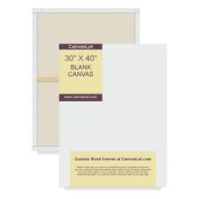
2 | Brushes Different Sizes(Rounded& Flat) | 1 pack | 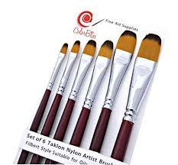
3 | Acrylic colors -150ml  (black, red, blue, yellow, orange, green ,purple) | 1 of each | 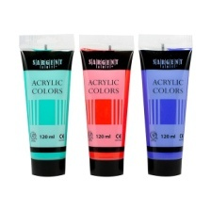
4 | Acrylic white paint “500 ml” | 1 | 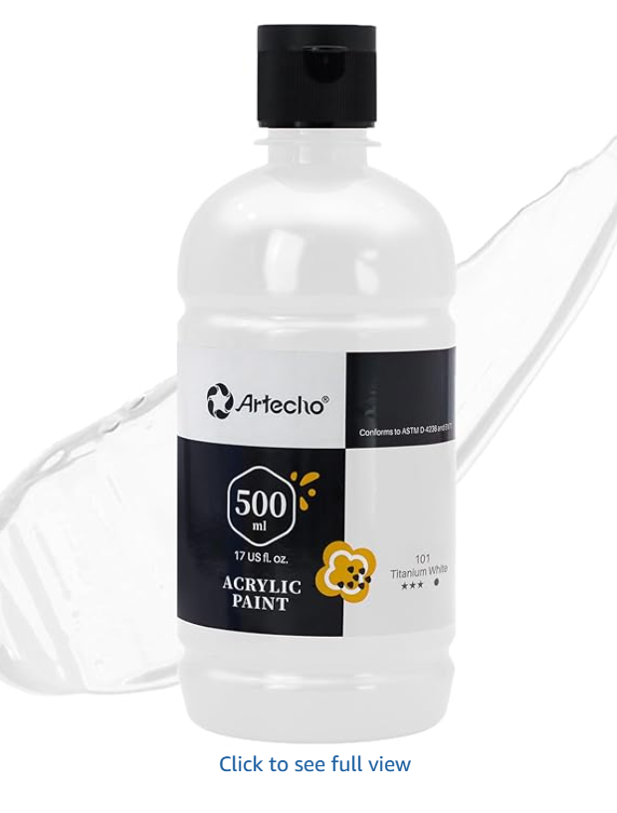
5 | Apron | 1 | 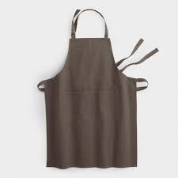
6 | White Glue + Uhu Glue | 1 | 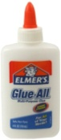,
7 | Fiber Castle Pencil colors  (pack of 24) | 1 | 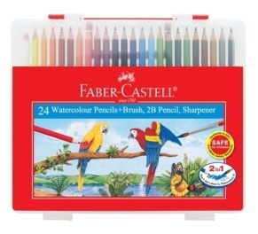
8 | Paint Markers | 1 | 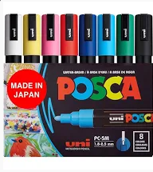
9 | Faber Castell Pencil | 1 | 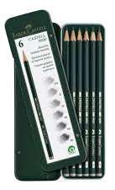
9 | Drawing book fabriano Size A3 | 1 | 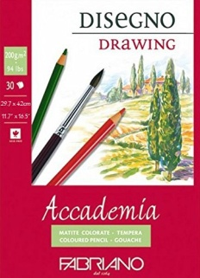
10 | Charcoal Sticks& Charcoal Eraser | 1 | 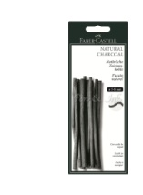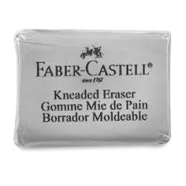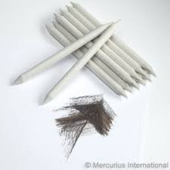
11 | Plastic ruler | 1
12 | Scissor | 1
13 | Eraser | 1
14 | Black Paint markers | 1 | 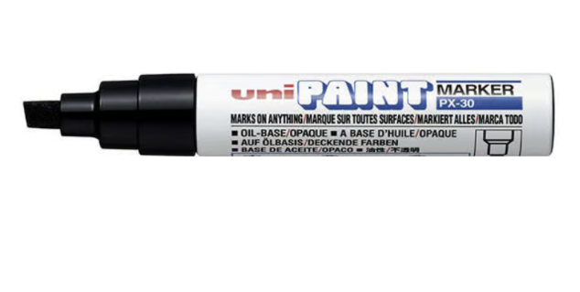
15 | Masking Tape |  | 